|  |  |  |  |
| --- | --- | --- | --- |
| Capstone Project |  | | Ang Zhen Xuan |
| Machine Learning Engineer Nanodegree | |  | 26th December 2017 |

Quora Question Pairs

# Definition

# Project Overview

**Domain Background**

Over 100 million people visit Quora every month, so it's no surprise that many people ask similarly worded questions. Multiple questions with the same intent can cause seekers to spend more time finding the best answer to their question, and make writers feel they need to answer multiple versions of the same question. Quora values canonical questions because they provide a better experience to active seekers and writers, and offer more value to both groups in the long term.

**Datasets and Inputs**

Dataset obtained from: <https://www.kaggle.com/c/quora-question-pairs/data>

Input variables of the train.csv include:

Independent variables

* id - the id of a training set question pair
* qid1, qid2 - unique ids of each question (only available in train.csv): question1, question2

Dependent variables

* is_duplicate - the target variable, set to 1 if question1 and question2 have essentially the same meaning, and 0 otherwise.

The question1 and question2 text will be cleansed on (through stemming and stop words, etc) prior to the training of the machine learning models. Said model is trained on the training dataset to prevent implicit bias infused into the trained model by ‘peeking’ into the test model[1]. while testing is done on the testing dataset. The accuracy obtained from comparing the model procured answers and the labels on the testing set can be used as a decent gauge for the performance of the machine learning techniques adopted in training.

**Presence of noise**: Human labelling is also a 'noisy' and inherently subjective process, and reasonable people will disagree. Thus, the ground truth labels on this dataset should be taken to be 'informed' but not 100% accurate, and may include incorrect labelling.

**Imbalanced classes**: The imbalance brought out by labelled classes needs to be addressed as 149,263 examples are labelled with 1, and the majority examples are labelled with 0. This is an issue to be addressed either by oversampling/undersampling methods[2].

I originally planned to use the following pre-trained word embeddings (resources shared on Kaggle[3]):

1. Google's word2vec embedding from [this link](https://code.google.com/archive/p/word2vec/)
2. Glove word vectors from [this link](https://nlp.stanford.edu/projects/glove/)
3. Facebook's fastText embeddings from [this link](https://github.com/facebookresearch/fastText/blob/master/pretrained-vectors.md)

Only the word2vec embedding from Google was utilized since I was computing with limited resources (on dual-core CPUs).

# Problem Statement

Currently, Quora uses a Random Forest model to identify duplicate questions. By tackling this natural language processing problem by applying advanced techniques to classify whether question pairs are duplicates, will make finding high quality answers to questions easier. This would result in an improved experience for Quora writers, seekers, and readers. I used the sklearn library’s RandomForestsClassifier to replicate a simple benchmark prediction model to be compared against.

The accuracy of the trained model must be able to quantify well enough (in the accuracy sense, to justify the use of the benchmarked Random Forest classifier or any subsequent prediction model to be used after training) as well as be able to generalize well enough to new question pairs.

I adopted the Keras wrapper with Tensorflow as its backend to train the Manhatten distance LSTM[4] (MaLSTM for short) model. The NLTK library was also used on the word vectors of the question pairs to help tokenize word into vectors, facilitating model training.

# Metrics

It was mentioned that Quora uses a model based on Random Forests to detect similarities between questions. The competition requires participants to generate predicted probabilities for the submission file, I sought to minimise the error based on the weighted log-loss function instead of the conventional metric accuracy as we do not have a “untouched” test dataset[5] with labels to train on.

I simulated a simple Random Forest model, and used it as a benchmark against the MaLSTM.

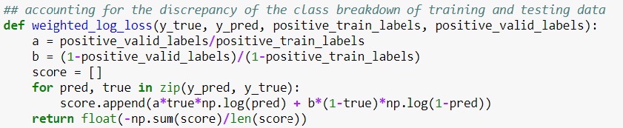

*Figure 5: Weighted log-loss function used in training the RandomForests classifier*

The weighted log-loss function was derived from the hold-out test set that I plan to use to evaluate the effectiveness of the prediction models. The test dataset has a label split of 83% non-duplicates and 17% of duplicates compared to the 63-37 split in the training dataset. Accounting for the difference in distributions between both datasets, the weighted log-loss function was derived based on the Bayes’ Theorem[6].

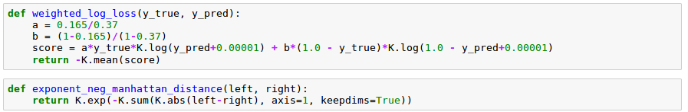*Figure 6: Weighted log-loss function re-written for the Keras’ library - used in training the Siamese maLSTM classifier*



*Figure 7: maLSTM similarity function*

The similarity function is used in the MaLSTM model to capture the similarity between questions in terms of their semantic and syntatic behaviour. Reducing the total weighted log loss is still the main aim of the MaLSTM model.

# Analysis

# Data Exploration & Exploratory Visualization

Referencing Figure 2, the percentage of duplicates to non-duplicates is as shown:

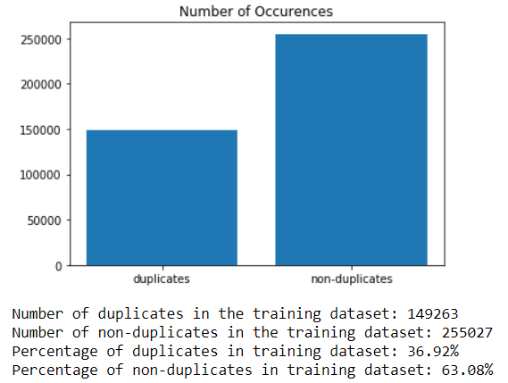

*Figure 1: Amount and Percentage of duplicates to non-duplicates in the training dataset*

This puts me in good stead with regards to the distribution of the training dataset. Next, I looked into the null values contained within the training distribution. This was easily achieved using **info()** method on my **train** DataFrame.

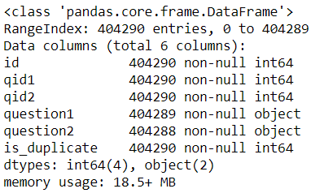

*Figure 2: Checking the null values that may need to be handled*

As shown in the figure above, both the question1 and question2 rows show a count of non-null objects that is less than the total number of question pairs in the training dataset (404289 and 404288 respectively). This proves that there are two null values in the question2 column while there exists one null value in the column of question1.

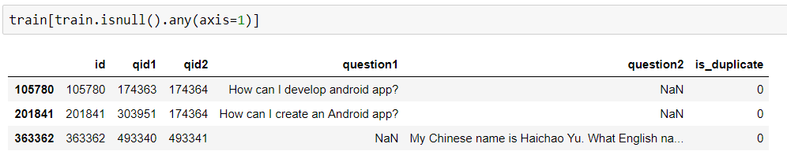

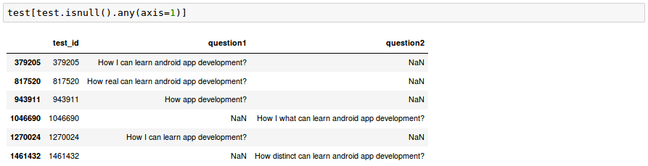

*Figure 3: Making sure the non-null rows are actually NaN values*

# Algorithms & Techniques

Neural networks are adaptable, and have been gaining traction in the field for handling word vectors yielding comparable results to classical measures like Cascading Features and Shallow Join Training for Natural Language Processing problems[7].

My original intention of training a model based on Convolutional Neural Networks (CNN) over RNNs was due to the fact that RNNs are slower and fickler to train, and sequencing may not be that important[8] as ‘feelings’ detection (such as happiness or sadness) in corpora may be more essential.

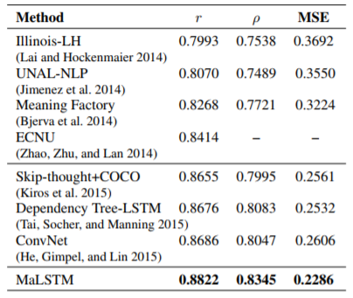

*Figure 8: Referencing the MSE column, it has the lowest error rate compared to the other models based on the SICK semantic similarity task.*

However, after further research, I realised that the Siamese Manhatten LSTM (MaLSTM)[9] provides a rather straightforward approach to the problem of sentence similarity. With reference to Figure 1, the MaLSTM has outperformed its counterparts (similar semantic handling models) by obtaining the lowest mean squared error on the SICK (Sentences Involving Compositional Knowledge) dataset – usually used to gauge performances of models with regards to accounting for syntactic and semantic issues[10]. It has also proven to perform well especially in tasks such as semantic similarity, which has been essential to solving Natural Language Processing problems in recent times.

# Benchmark

I seek to minimise the weighted log loss that was defined in the Metrics section, as well as minimizing the error achieved on the public and private leaderboards as a gauge of my attempt relative to the Kaggle leaders. The top half of the public and private leaderboards require a Leaderboard (LB) score of and respectively. I believe that being placed at the top 10% of the leaderboard would warrant the algorithm for Quora’s use in predictions (or at least provide a good model for them to start with).

# Methodology

# Data Preprocessing

I replace the null values with empty strings to ensure that the null values are handled in a proper manner – without compromising of potential predictive power in the case of empty inputs. I also ensure that the two question rows tally with the amount of null values.

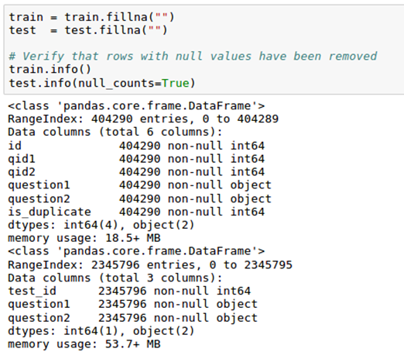

*Figure 4: Replacing N.As with empty strings*

# Implementation

I started building the benchmark Random Forests classifier by data engineering on a couple of features.

Features include:

1. The number of words in a question
2. The average word length in a question
3. The total number of letters in a question
4. The number of sentences that start off with a capitalized letter in a question
5. The Jaccard index/Similarity Coefficient - the Bag-Of-Words variant[11] between two questions
6. Levenshtein distance between two questions[12]

I used the RandomForestsClassifier[13] module to train my prediction model, with only the number of Random Forests (n_estimators) as a tunable hyperparameter. I also adopted the grid search process on a 10-fold cross validation dataset. The scikit-learn library GridSearchCV makes it easy to tune the hyperparameters while validating the results against the split sets.

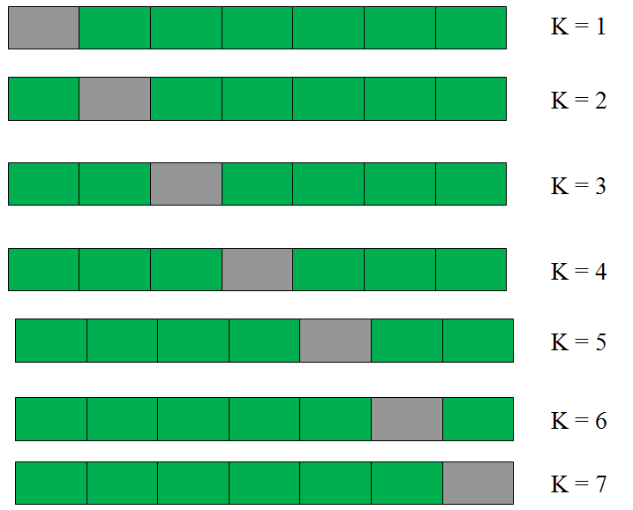

*Figure 9: k-fold (k=7) cross validation training – the grey areas are the validation sets while the green blocks sum up to be the training dataset in each iteration*

# Refinement

Looking at the rather disappointing results of my Random Forest classifier, and the trouble in which the Keras library have eased to train neural nets, I decided to pivot to a deep learning Siamese maLSTM classifier built by word embeddings as features. In addition, the classical features do not provide explainable insights to the results that I have obtained after training

I adopted Google’s corpus as their pre-trained word embeddings have been trained on three million english words which should constitute as extensive for my use case. The pre-trained embeddings also mean that I do not have to train my own word embedding which may take an awful of long time for a model powered by a CPU.

Firstly, I had to define the architecture of the Siamese maLSTM model, which was discussed extensively in this Medium article[14].

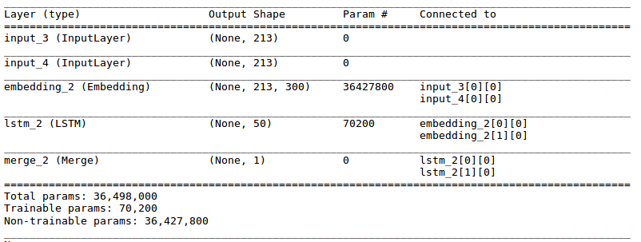*Figure 9: Architecture of the Siamese LSTM model*

I proceeded to process the inputs for the model – generating the word matrix for my word embeddings. This is done in a couple of steps:

1. Splitting the training dataset (**train.csv**) into a 80-20 split, using the 20% as a validation set of sorts to ensure better generalization can be achieved to achieve better results on the holdout test set on Kaggle.
2. Cleaning the datasets through importing NLTK’s stopwords as well as a couple of regex formatting to ensure words are consistent (hasn’t is converted into has not for example).
3. Iterate through every sentence in both columns of both the training and testing datasets.
4. Since word vectors cannot be inputted and trained upon, they have to be converted into a numerical representation before training
5. Keep a dictionary record of every word in that has appeared, as well as holding another array with the numerical representations of each and every word of my dictionary.
6. Filling the matrix with each word’s 300 dimensional representation. The matrix should be a |D|[15] x |300|

Regarding the tuning of the parameters, I decided to manually handpick a few values for the tunable hyperparameters such as the number of epochs, the number of hidden layers as well as the batch size. In addition, dropout layers were placed after the LSTM layers as an attempt to improve the results - through the prevention of overfitting the training data.

# Results

# Model Evaluation & Validation

The final model’s parameters were as such:

* 50 hidden layer nodes
* Batch size of 1024
* 10 epochs
* Adam optimizer, clipping the norm at a value of 0.9

I obtained a bigger batch size due to the fact that the training data was really huge and it took way too long to finish training the model. The number of epochs chosen was to allow the validation loss to stabilize (either through locating some better local optima or not moving back to a shallower local optima). The Adam optimizer was adopted as it is usually deemed the best optimizer by most, while the clipping norm option was adopted as a counter measure against exploding gradients.

|  |  |  |  |  |
| --- | --- | --- | --- | --- |
|  | Metric | Weighted Log-Loss Error | Kaggle Leaderboard (LB) score | |
| Model |  | Public | Private |
| Random Forests Classifier w/ 10-fold CV | | 2.81428114447 | 0.59123 | 0.58364 |
| Siamese MaLSTM w/ pre-trained word embeddings | | 0.290278734785 | 0.34697 | 0.35206 |

*­Figure 10: Comparing metrics & results*

# Justification

The results were compared for both models with reference to Figure 10. A marked improvement in every metric that I have sought to compare for my original benchmark model and the refined model was observed.

I believe with the huge reduction in the weighted log-loss error which accounts for the imbalance in the dataset, as well as the huge drop in the LB score on Kaggle, I think the pivoting of model from a Random Forests classifier to a Siamese MaLSTM that better captures the similarity or lack thereof between questions was a justified decision. Last but not least, I managed to achieve a top half (45th percentile) position with that LB score. Given that my computing power was limited, I believe I could have achieved a better score through more rigorous testing given a better GPU.

# Conclusion

# Free-Form Visualization

# Reflections

Natural Language problems have been and are still a challenging form of issue to deal with. Even though much progress has been established within the field of Deep Learning and Machine Learning, great results that we may have achieved - may not mean that our prediction models have captured the semantic, syntactic meaning behind words.

Given that this was the first time I was exposed to the idea of Siamese LSTMs, I took a fair bit of research before I understood what was going on. During the training phase, it struck me - that the idea of Siamese comes in the form of their symmetrical input layers!

I do understand the limitations of my own solutions, due to the lack of computing power I had. I was unable to use the grid search process on cross validated sets as I did for my Random Forests classifier, which could have potentially arrived at a better **loss** local optima or the global optima (which I sought to minimise).

# Improvements

In conclusion, after rigorous testing and tuning of the prediction model’s parameters, I believe there are a few points we can conclude for the end model:

1. Firstly, transfer learning could be applied to our initial weights – pre-train MaLSTM on separate sentence-pair data provided in the SemEval 2013 Semantic Textual Similarity paper instead of randomly drawing weights from a Gaussian distribution. This has **proven to be a superior starting point compared to random initialization[16].**
2. **More data usually provides more robust and reliable prediction models.**
   1. Generate possible new data, be it manually or through generative deep learning systems such as the GAN (Generative Adversarial Networks) to be used in the training processes.
   2. Possibly replace words with their synonyms to obtain more training data.
3. The word embeddings from Google that I have utilized may not have been the best contextual corpus to derive weights from as Google’s corpus was based on news articles and reports. This corpus may not be providing totally relevant context to my corpus of sentences from a diversity of categories on Quora. **This is likely to lead to a better accuracy with more relevance to the broadness of categories Quora is likely to cover.**
4. Lastly, the classical features could have been expanded on as the number of features were limited – might not have resulted in a representative Random Forests classifier.

All in all, the points discussed above may or may not lead to a better score or accuracy, but they do warrant as potential points of improvements that I could look into.

1. Abu-Mostafa, Y. S., Magdon-Ismail, M., & Lin, H. (2012). *Learning from data: a short course*. S.l.: AMLbook.com. Chapter 5 – Three Learning Principles.
2. Dealing with class imbalance while using CNNs. <http://www.academia.edu/8472416/Tackling_Class_Imbalance_with_Deep_Convolutional_Neural_Networks>
3. Word embeddings resources shared on Kaggle -

   <https://www.kaggle.com/c/quora-question-pairs/discussion/30286>
4. Original paper published for the MaLSTM model - <http://www.mit.edu/~jonasm/info/MuellerThyagarajan_AAAI16.pdf>
5. Data snooping & related isseus - <https://work.caltech.edu/library/173.html>
6. Accounting for differences in training and test dataset’s distributions - <https://swarbrickjones.wordpress.com/2017/03/28/cross-entropy-and-training-test-class-imbalance/>
7. Collobert, R., & Weston, J. (2008). A unified architecture for natural language processing. *Proceedings of the 25th international conference on Machine learning - ICML 08*. doi:10.1145/1390156.1390177
8. Reasons relating to picking CNN over RNN - <https://datascience.stackexchange.com/questions/11619/rnn-vs-cnnat-a-high-level>
9. How to predict Quora Question Pairs using Siamese Manhattan LSTM - <https://medium.com/mlreview/implementing-malstm-on-kaggles-quora-question-pairs-competition-8b31b0b16a07>
10. The SICK dataset - <http://clic.cimec.unitn.it/composes/sick.html>
11. Explanation of the difference between the Bag-of-Words and Frequency Distribution variants of the Jaccard index - <https://nickgrattandatascience.wordpress.com/2017/12/31/bag-of-words-and-frequency-distributions-in-c/>
12. Levensthein distance as covered by Wikipedia - <https://en.wikipedia.org/wiki/Levenshtein_distance>
13. RandomForestsClassifier - <http://scikit-learn.org/stable/modules/generated/sklearn.ensemble.RandomForestClassifier.html>
14. Architecture discussed in this article - <https://medium.com/mlreview/implementing-malstm-on-kaggles-quora-question-pairs-competition-8b31b0b16a07>
15. It should equate to the number of words collected by the dictionary in step 2.
16. SemEval 2013 Semantic Textual Similarity - <http://citeseerx.ist.psu.edu/viewdoc/download;jsessionid=36B3188663E26B1D311592D8757A11B7?doi=10.1.1.310.7053&rep=rep1&type=pdf>